Contents

CASE Tools 2

Components of CASE Tools 2

Central Repository 2

Upper CASE Tools 2

Lower CASE Tools 3

Integrated CASE Tools 3

CASE Tools Types 3

Diagram tools 3

Process Modeling Tools 3

Project Management Tools 4

Documentation Tools 5

Analysis Tools 5

Design Tools 6

Configuration Management Tools 6

Change Control Tools 7

Programming Tools 8

Prototyping Tools 8

Web Development Tools 9

Quality Assurance Tools 9

Maintenance Tools 10

# CASE Tools

CASE stands for Computer Aided Software Engineering. It means, development and maintenance of software projects with help of various automated software tools.

CASE tools are set of software application programs, which are used to automate SDLC activities. CASE tools are used by software project managers, analysts, and engineers to develop software system.

There are number of CASE tools available to simplify various stages of Software Development Life Cycle such as Analysis tools, Design tools, Project management tools, Database Management tools, Documentation tools are to name a few.

Use of CASE tools accelerates the development of project to produce desired result and helps to uncover flaws before moving ahead with next stage in software development.

# Components of CASE Tools

CASE tools can be broadly divided into the following parts based on their use at a particular SDLC stage:

Central Repository

CASE tools require a central repository, which can serve as a source of common, integrated, and consistent information. Central repository is a central place of storage where product specifications, requirement documents, related reports and diagrams, other useful information regarding management is stored. Central repository also serves as data dictionary.

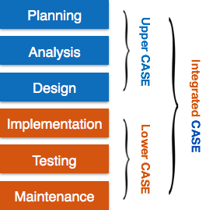

Upper CASE Tools

Upper CASE tools are used in planning, analysis and design stages of SDLC.

Lower CASE Tools

Lower CASE tools are used in implementation, testing and maintenance.

Integrated CASE Tools

Integrated CASE tools are helpful in all the stages of SDLC, from Requirement gathering to Testing and documentation.

CASE tools can be grouped together if they have similar functionality, process activities and capability of getting integrated with other tools.

# CASE Tools Types

## Diagram tools

These tools are used to represent system components, data and control flow among various software components and system structure in a graphical form. For example, Flow Chart Maker tool for creating state-of-the-art flowcharts.

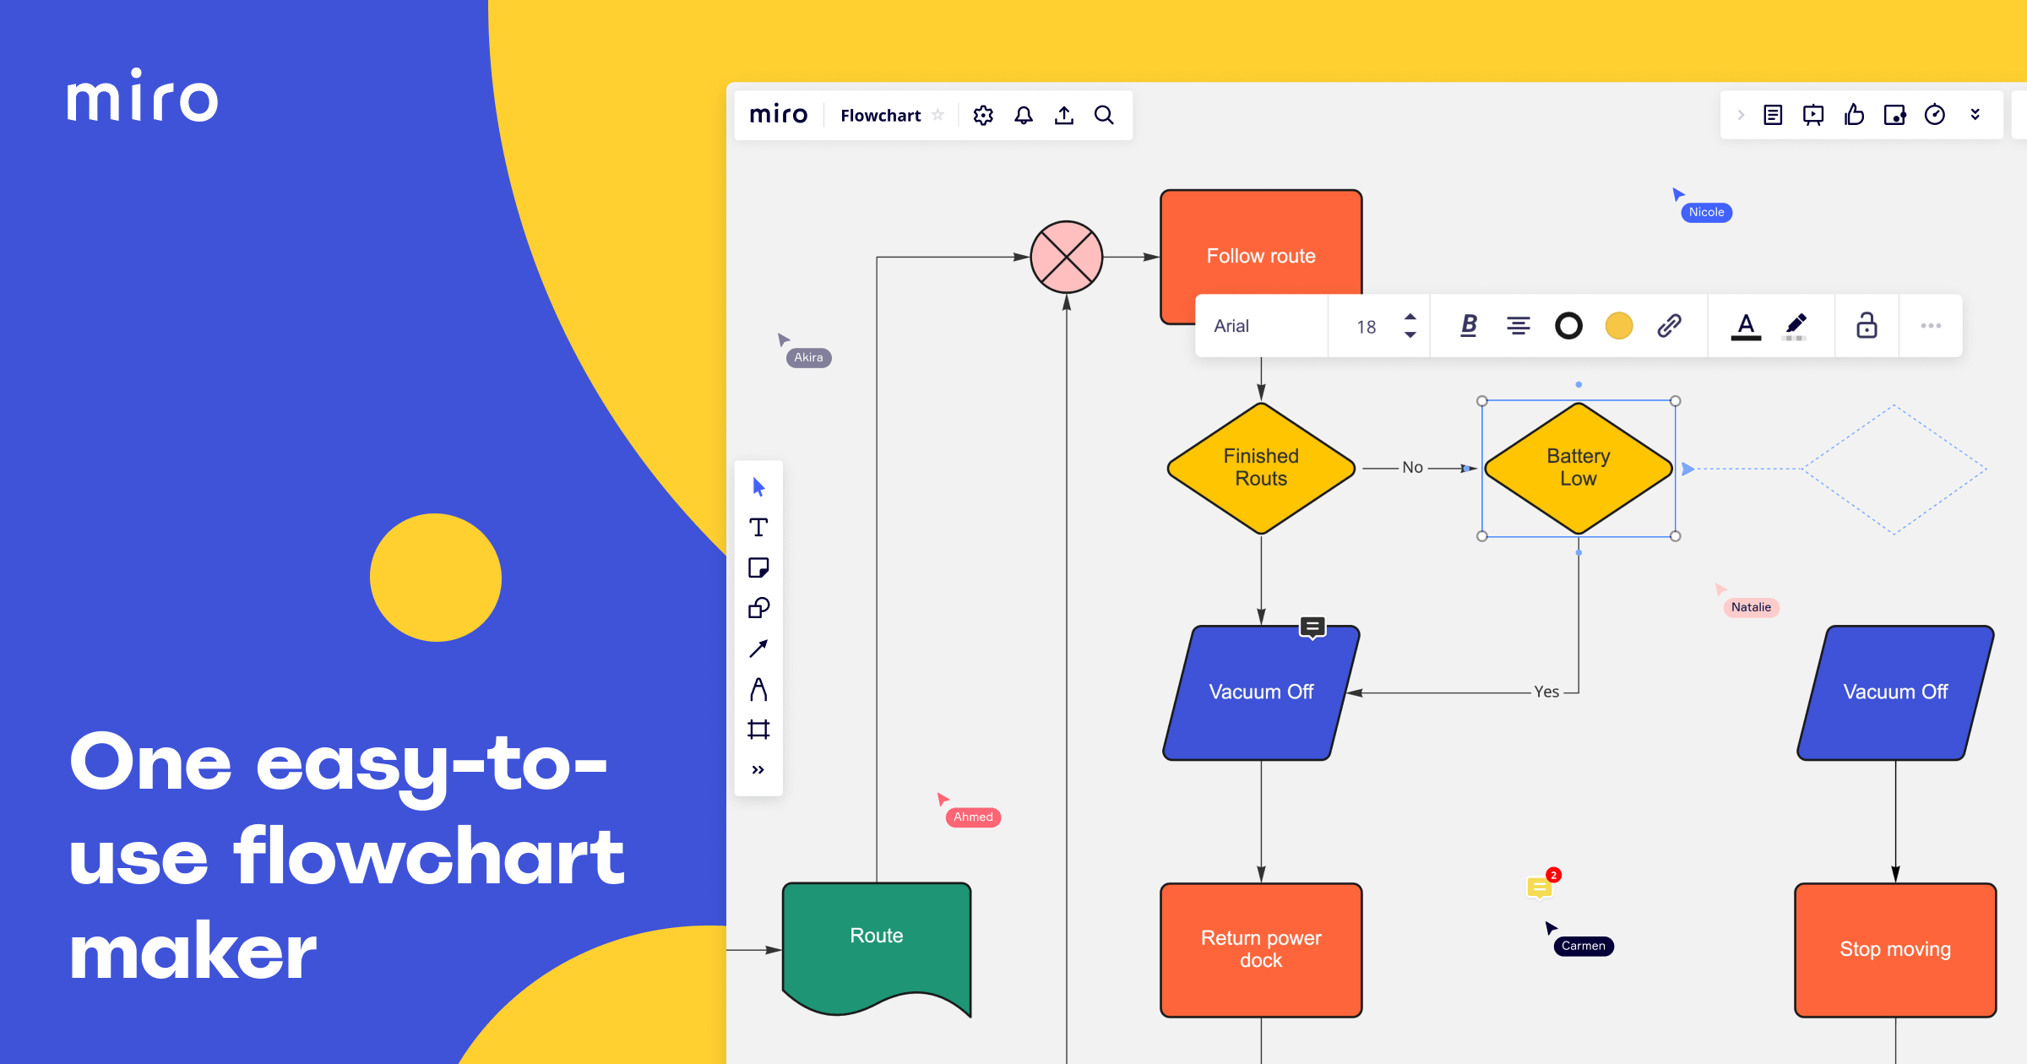

## Process Modeling Tools

Process modeling is method to create software process model, which is used to develop the software. Process modeling tools help the managers to choose a process model or modify it as per the requirement of software product. For example, EPF Composer

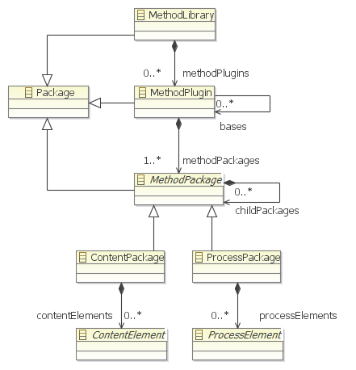

## Project Management Tools

These tools are used for project planning, cost and effort estimation, project scheduling and resource planning. Managers have to strictly comply project execution with every mentioned step in software project management. Project management tools help in storing and sharing project information in real-time throughout the organization. For example, Creative Pro Office, Trac Project, Basecamp.

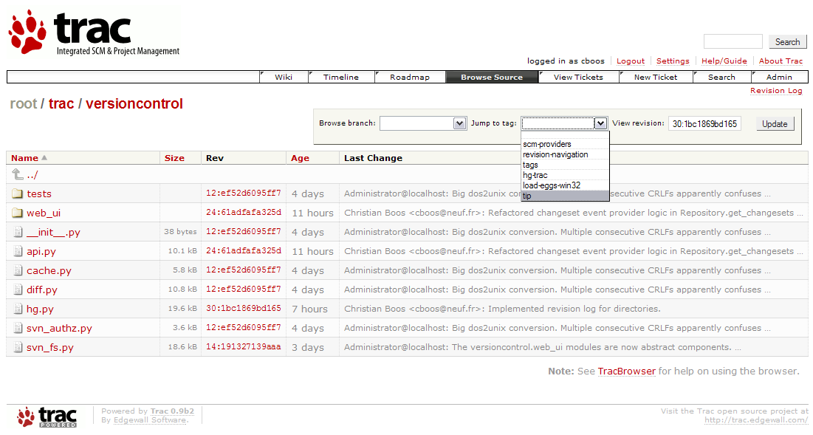

## Documentation Tools

Documentation in a software project starts prior to the software process, goes throughout all phases of SDLC and after the completion of the project.

Documentation tools generate documents for technical users and end users. Technical users are mostly in-house professionals of the development team who refer to system manual, reference manual, training manual, installation manuals etc. The end user documents describe the functioning and how-to of the system such as user manual. For example, Doxygen, DrExplain, Adobe RoboHelp for documentation.

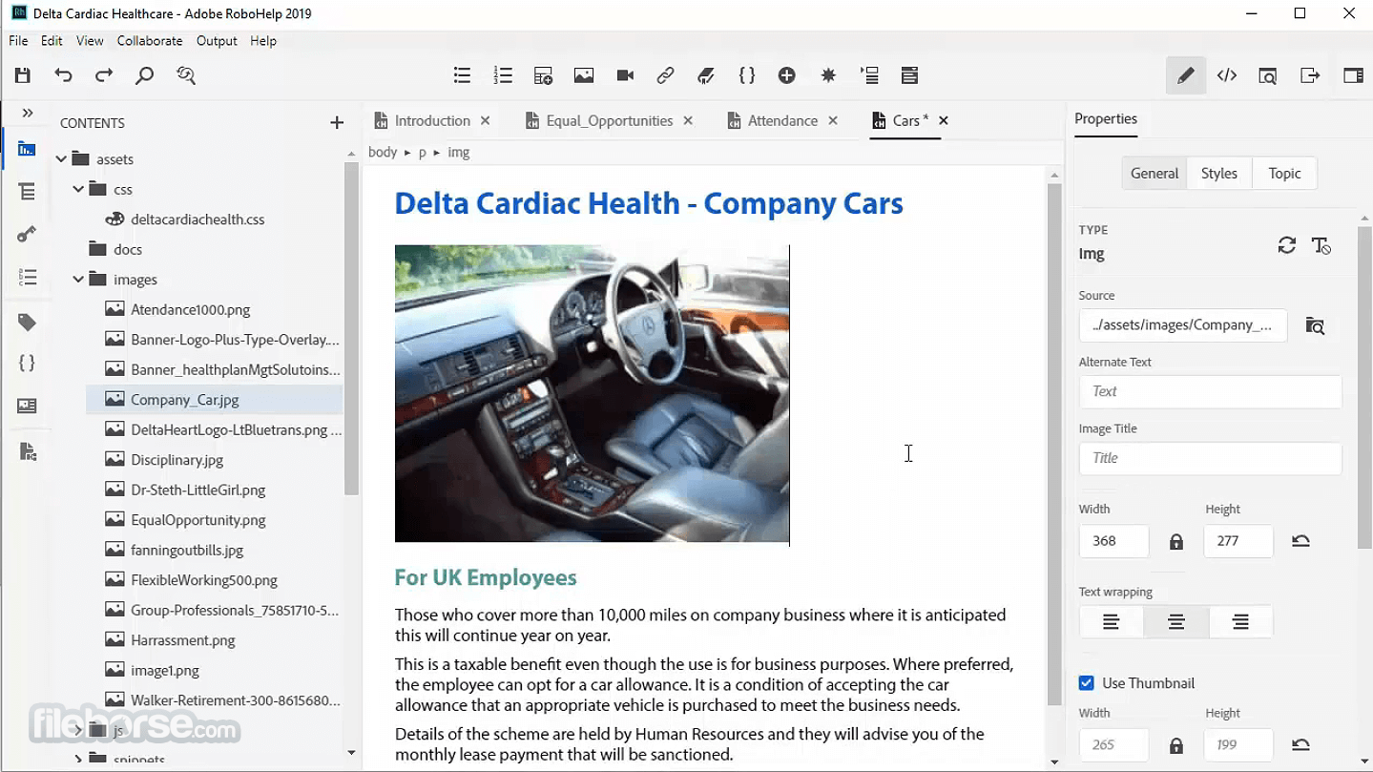

## Analysis Tools

These tools help to gather requirements, automatically check for any inconsistency, inaccuracy in the diagrams, data redundancies or erroneous omissions. For example, Accept 360, Accompa, CASEComplete for requirement analysis, Visible Analyst for total analysis.

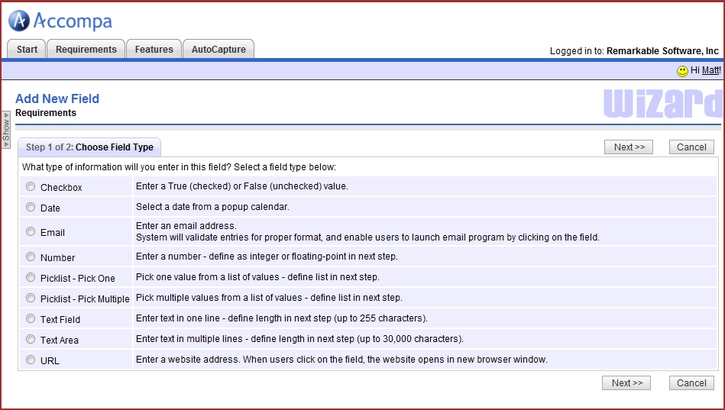

## Design Tools

These tools help software designers to design the block structure of the software, which may further be broken down in smaller modules using refinement techniques. These tools provides detailing of each module and interconnections among modules. For example, Animated Software Design

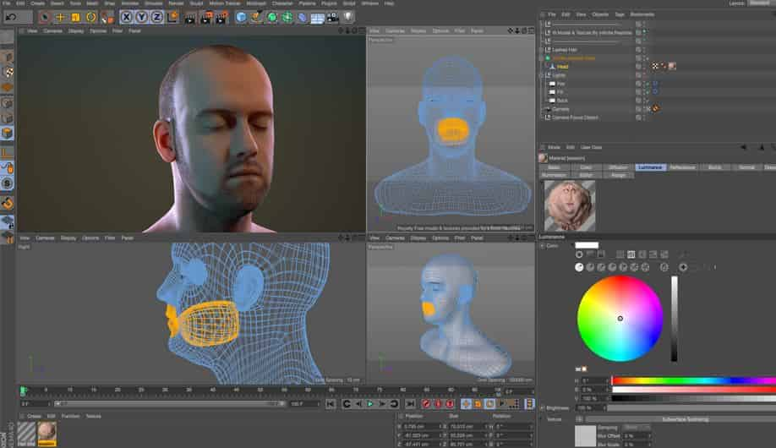

## Configuration Management Tools

An instance of software is released under one version. Configuration Management tools deal with:

* Version and revision management
* Baseline configuration management
* Change control management

CASE tools help in this by automatic tracking, version management and release management. For example, Fossil, Git, Accu REV.

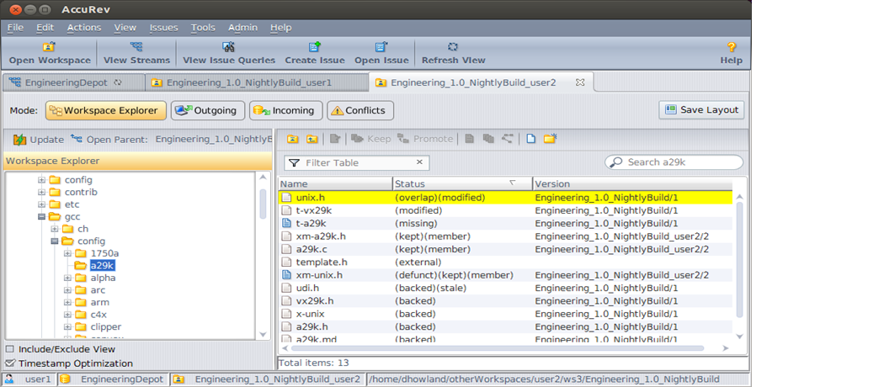

## Change Control Tools

These tools are considered as a part of configuration management tools. They deal with changes made to the software after its baseline is fixed or when the software is first released. CASE tools automate change tracking, file management, code management and more. It also helps in enforcing change policy of the organization. For example StarTeam.

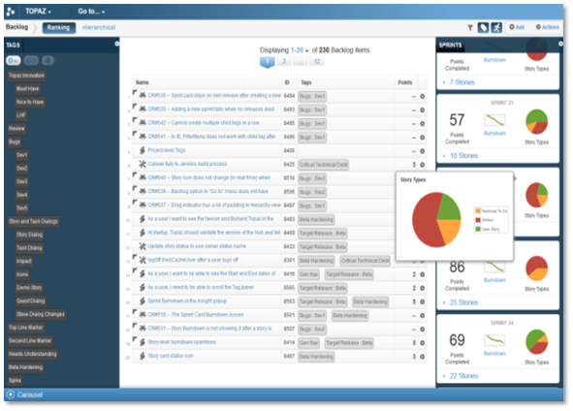

## Programming Tools

These tools consist of programming environments like IDE (Integrated Development Environment), in-built modules library and simulation tools. These tools provide comprehensive aid in building software product and include features for simulation and testing. For example, Cscope to search code in C, Eclipse.

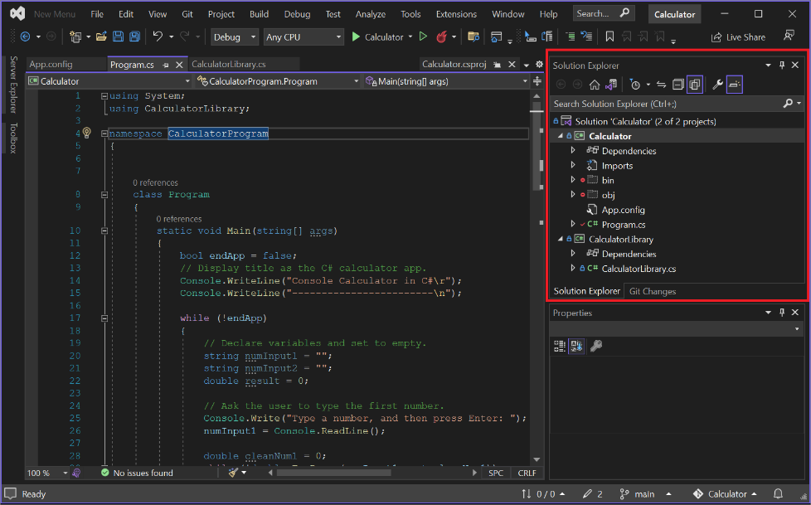

## Prototyping Tools

Software prototype is simulated version of the intended software product. Prototype provides initial look and feel of the product and simulates few aspect of actual product.

Prototyping CASE tools essentially come with graphical libraries. They can create hardware independent user interfaces and design. These tools help us to build rapid prototypes based on existing information. In addition, they provide simulation of software prototype. For example, Serena prototype composer, Mockup Builder.

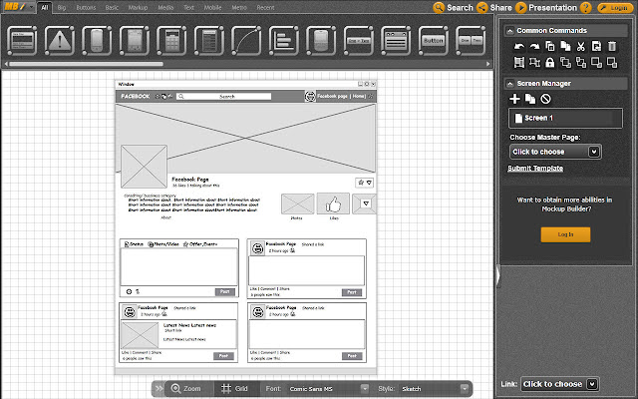

## Web Development Tools

These tools assist in designing web pages with all allied elements like forms, text, script, graphic and so on. Web tools also provide live preview of what is being developed and how will it look after completion. For example, Fontello, Adobe Edge Inspect, Foundation 3, Brackets.

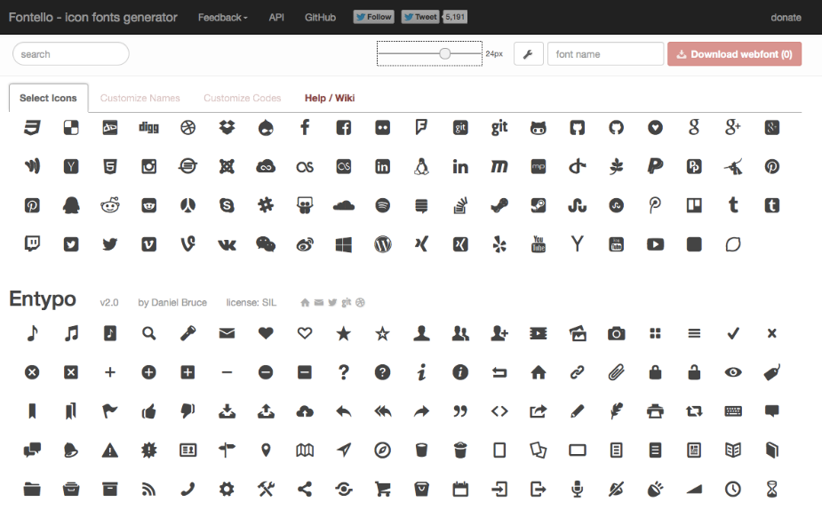

## Quality Assurance Tools

Quality assurance in a software organization is monitoring the engineering process and methods adopted to develop the software product in order to ensure conformance of quality as per organization standards. QA tools consist of configuration and change control tools and software testing tools. For example, SoapTest, AppsWatch, JMeter.

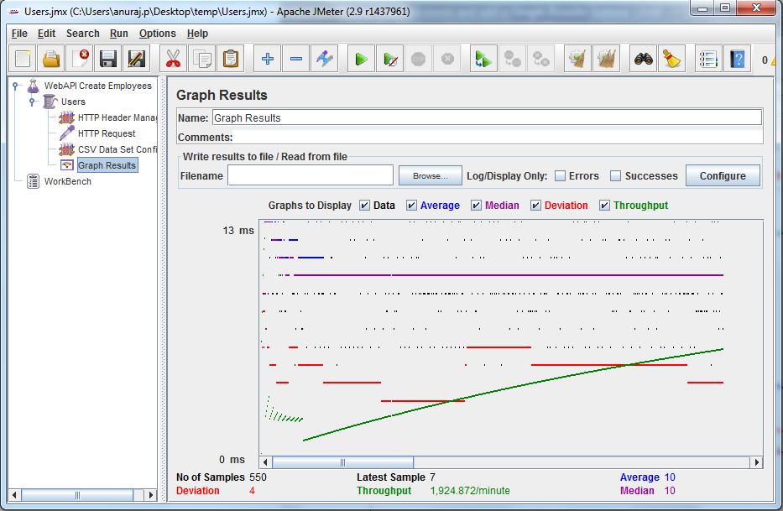

## Maintenance Tools

Software maintenance includes modifications in the software product after it is delivered. Automatic logging and error reporting techniques, automatic error ticket generation and root cause Analysis are few CASE tools, which help software organization in maintenance phase of SDLC. For example, Bugzilla for defect tracking, HP Quality Center.

